

7CS044 -Project Management

School of Mathematics and Computer Science Faculty of Science and Engineering

Innovation Report

Coursework Individual Assignment

**AGBOOLA TEMIREMI ADEGBAMIGBE**

**2063529**

**May 20, 2022**

# SUMMARY

This report discusses an example of a machine learning technique (I.e., decision tree method) used in detecting money laundering transactions in the Nigerian banking system. The framework demonstrates the effectiveness of decision tree in generating AML (Anti- Money Laundering) rules from customer details in banks.

# CONTENTS

Summary 2

1. Description of the Sector 4
2. Description of the Innovation 6
3. Plan for Deployment 8
   1. GANTT Chart 8
4. Conclusion 10
5. References 11

**THE FINANCIAL INDUSTRY**

Money laundering (ML) is tagged as a criminal activity and a threat to the financial industries. Therefore, it is highly essential for financial institutions to technologically empower themselves and adopt a more digitalized approach to tackle it.

Money laundering is the illegal process of making “dirty” money look legitimate. It has become a major challenge and financial organizations have been fighting tooth and nail to stop it.

How money laundering works, the 3 Stages of ML are:

**Placement** – (funds are move from direct association with the crime)

**Layering** – (disguising by breaking down large bulk funds into a series of smaller transactions)

**Integration** - (making the money available by integrating it back into the criminal’s legitimate accounts)

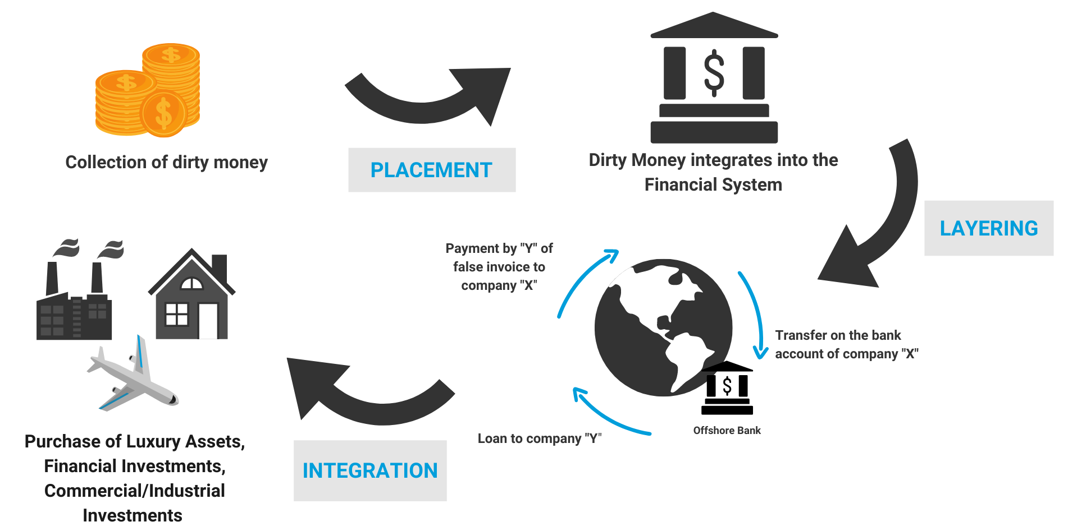

**Fig 1: An illustration of the ML Cycle (United Nations Office on Drugs Crime)**

**CREATING AN EFFECTIVE AML SYSTEM PROGRAM.**

The KYC **“Know you customer”** program is a decision tree method for assessing banks’ customer. This well assist in detecting money laundered through the banking system.

**PROJECT APPROACH**

* Identifying suspicious activity and behavior and making appropriate decisions for escalation.
* Creating a well-defined, consistent and documented investigative process.
* Creating an effective management reporting framework.
* Developing a strong AML culture.

**Risk based- Approach**

The project will employ effective measures such as EDD (enhanced due diligence) so as to effectively manage risk. The risk level will be classified into three. **L- low’,** ‘**M- middle**’ and ‘**H- high’** levels.

The risk money laundering will be identified in the following areas:

1) Customer’s business and industry

2) Customer’s location

3) Customer’s business size

4) Services or products offered to the customer

**Table 1**

**ML CLASS FOR INDUSTRIES**

|  |  |
| --- | --- |
| **Industry** | AML-Risk Level |
| Manufacture |  |
| Chemical |  |
| local Trade |  |
| Medicine |  |
| IT |  |
| Foreign trade |  |
| Retail |  |
| Advertisement |  |
| Automobile sales |  |

**Table 2**

**ML CLASS FOR LOCATIONS**

|  |  |
| --- | --- |
| **Location** | AML-Risk Level |
| Abuja |  |
| Lagos |  |
| South west |  |
| South east |  |
| South south |  |
| North |  |

**Table 3**

**ML CLASS FOR BUSINESS SIZE** b

|  |  |
| --- | --- |
| **Business Size** | AML-Risk Level |
| Listed |  |
| Small |  |
| Medium |  |
| Large |  |

**Table 4**

**ML CLASS FOR BANK PRODUCTS**

|  |  |
| --- | --- |
| **Banks' Products** | AML-Risk Level |
| Loan services |  |
| Internet banking service |  |
| Cash services |  |
| Deposits |  |
| Offshore services |  |
| Other services |  |

**DEPLOYMENT**

The key tasks that would be evaluated to execute a technology driven AML system successfully are.

1. **Project Planning**
2. **Financial/Resource Management**
3. **Change Management**

**GANTT CHART**

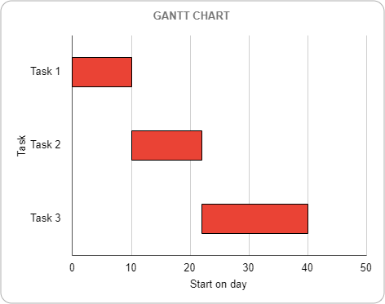

**Time Management**

|  |  |
| --- | --- |
| **Task** | **Time Estimate** |
| Project Planning | 10 days |
| Financial/Resource Management | 12 days |
| Change Management | 13 days |

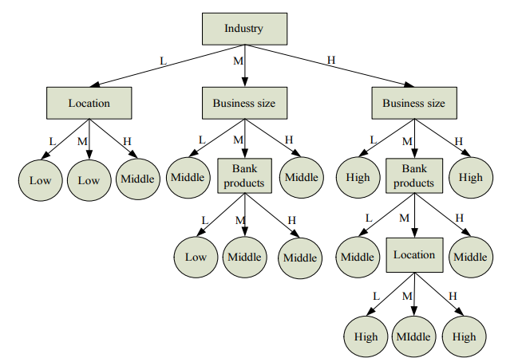

**Fig 2: A typical example of a decision tree used to determine customer’s money laundering risk**

**source:**  Money Laundering Risk Evaluation Method Based on Decision Tree by (Wang, Yang, 2007)

**CONCLUSION**

This report adopted a machine learning algorithm (decision tree) to create an effective AML system to detect and prevent suspicious transactions in the banking system.

**REFERENCES**

Safavian, S.R. and Landgrebe, D. (1991). A survey of decision tree classifier methodology. *IEEE Transactions on Systems, Man, and Cybernetics*, 21(3), pp.660–674. doi:10.1109/21.97458.

‌Quinlan, J.R. (1986). Induction of decision trees. *Machine Learning*, [online] 1(1), pp.81–106. doi:10.1007/bf00116251.

ACAMS Today. (2013). *Anti-money laundering transaction monitoring system implementation considerations*. [online] Available at: https://www.acamstoday.org/anti-money-laundering-transaction-monitoring-system-implementation-considerations/ [Accessed 23 May 2022].

United Nations: Office on Drugs and Crime. (n.d.). *Overview*. [online] Available at: https://www.unodc.org/unodc/en/money-laundering/overview.html.

Wang, S.-N. and Yang, J.-G. (2007). A Money Laundering Risk Evaluation Method Based on Decision Tree. *2007 International Conference on Machine Learning and Cybernetics*. doi:10.1109/icmlc.2007.4370155.

‌